QVINCI

Qvinci is a cloud-based reporting tool that works with QuickBooks. Qvinci automatically pulls P&L and Balance Sheet line items into their platform for visibility into parish finances. Users can chose between consolidated or side-by-side viewing of reports.

To access, your Pastor simply needs to email a request for access to Debbie Swisher at dswisher@cdlex.org. Debbie will need the name and email of the person who is requesting access. You will then receive an invitation via email with a link to Activate Qvinci Account.
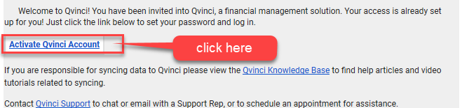

To return to Qvinci, simply go to www.qvinci.com
Enter your email and password
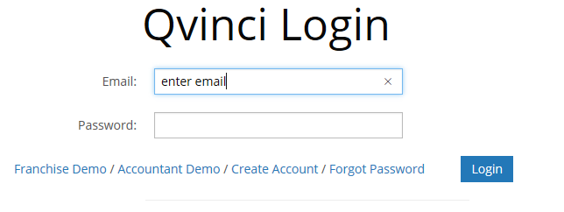

Once logged in you see your Dashboard. You can customize your dashboard by clicking on Select Widgets in the right corner of your screen.
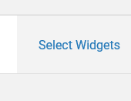

Customize your view using the arrows and the up and down. Save any changes.

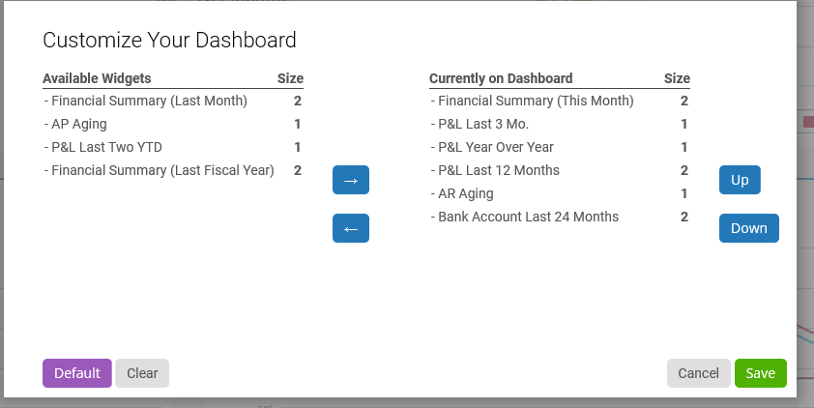

To run financial reports, click Reports & Libraries on the left side menu. Click Basic Reports.

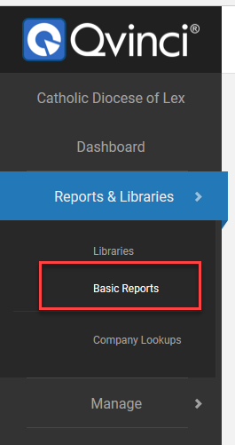

You now view the Create a New Report window. Select the report you wish to run simply by clicking the name.
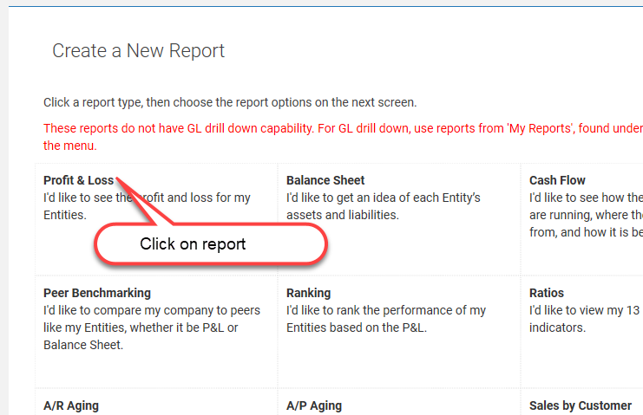

If you have access to multiple entities, you may need to filter to view reports for specific location(s). Click the Filter Entities Icon located on the center of the top of your screen.

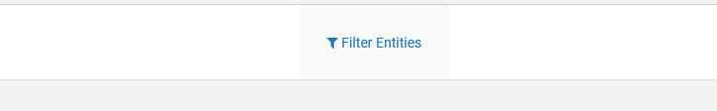

Click on the entities you wish to report. Note you may also filter by city, Deanery (division) etc. The default is Select All Entities.
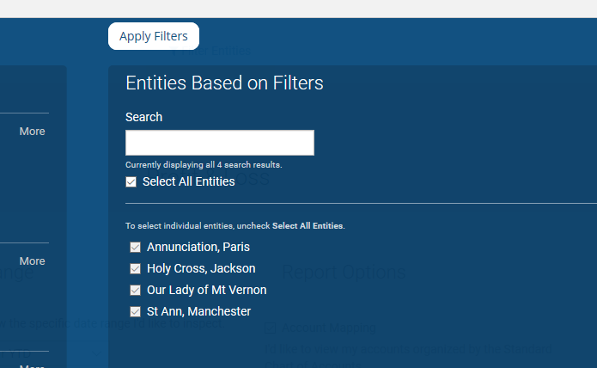

Click Apply Filters

You will return to My Reports. Note: the title will say My Reports on All Entities or will show My Reports on the number of entities you have selected.

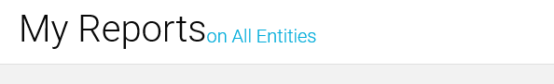
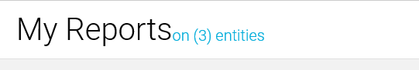

Next, select Frequency

Please note that when you have more than 1 entity selected, Totals will give you the total of all the selected entities together. You need to select by Entity to see each one side by side.

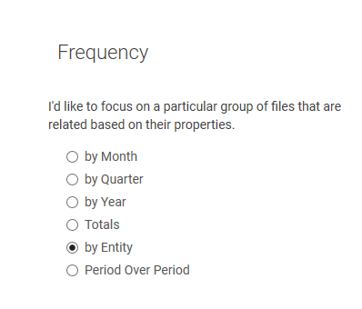

Select Date Range. Click the drop down to select a period or click the Use Custom Date Range box. Select a start and end date.

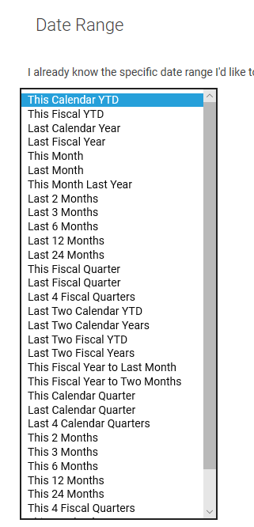

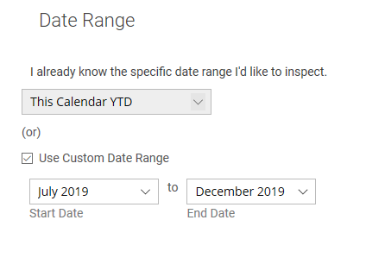

Last, select Report Options if applicable. The default is Account Mapping, which lets you view per our Standardized Chart of Accounts.

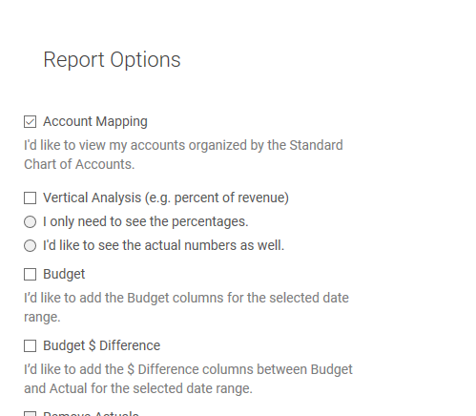

Once criteria is selected, scroll to the bottom of your screen and click Build My Report on the lower right side of screen.

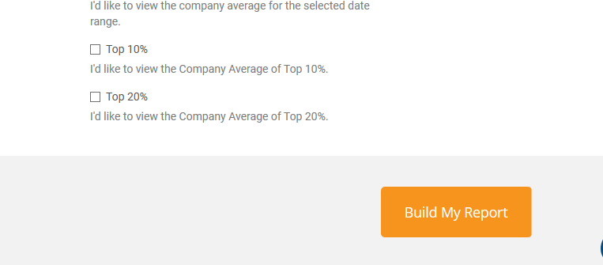

Your report displays on screen. You now have the option to export to a PDF, export to Excel or Save As to your own reports in Qvinci. All these options are located in the upper right hand corner of your screen.

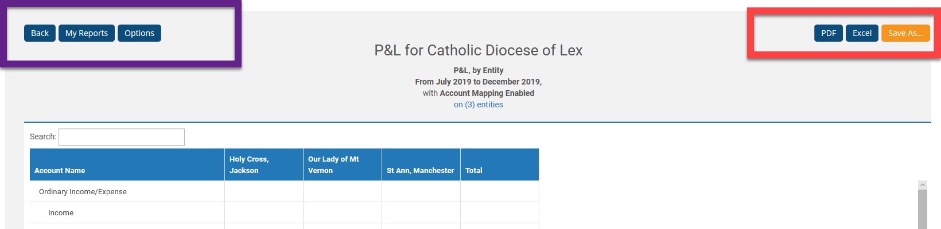

On the upper left side of screen, you have the option to just go back, go to My Reports, or click Options. Options takes you back to the criteria selections screen.

To save a specific report once you have formatted your criteria, select the Save As icon in the upper right corner. Name your report and click save.

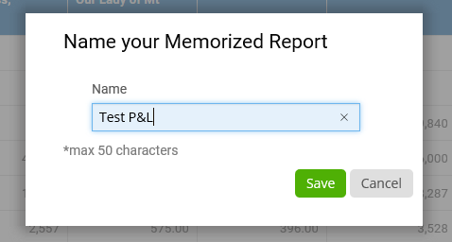

To retrieve your memorized report, go to Reports & Libraries. Click on Libraries.

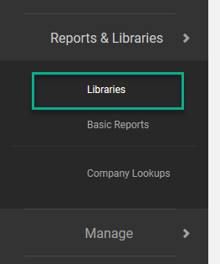

Be sure you are on the Mine tab.
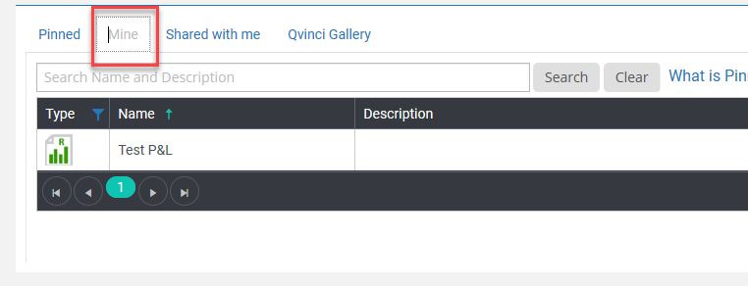

All saved reports will be listed.

To exit Qvinci, click the Logout on the left side menu.

